**Camera Basics**

Before you dive into taking photos, you need to understand how your equipment works. Learning about the features and mechanics of your camera – whether that’s a point-and-shoot, smartphone, or DSLR – is vital.

For example, knowing how to turn off the automatic flash, change the shutter speed or aperture, or even understanding the zoom function, can make or break your final photos. It’s always best to refer to your camera’s manual when understanding the specifics, but you can also refer to our resource on [how to take good pictures with your smartphone](https://www.shutterfly.com/ideas/how-to-take-good-pictures/) for phone based photography basics.

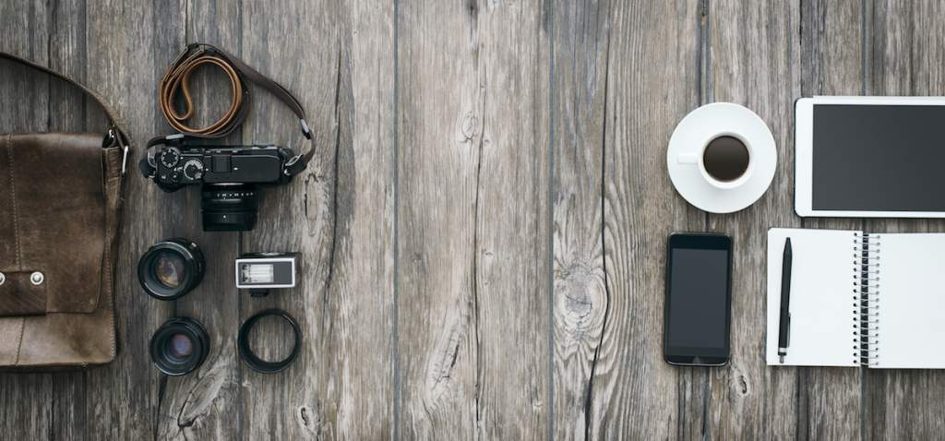

Camera Features For Beginners

* Viewfinder (and grid mode): You can use the viewfinder to help strategize the composition of your photo. Grid mode turns on a helpful planning grid within the screen.
* Zoom: While it’s generally recommended to stay away from zooming, as this reduces quality in pictures, it’s important to understand the limitations and benefits of your camera’s zoom.
* Focus: Most cameras come with auto focus, but you should also figure out how to change this setting to manual once you get comfortable with other photography basics. This will help you take more visually interesting photos.
* Color Balance: Adjust your color balance settings depending on the lighting to help make sure your photos don’t come out in undesired colors.
* Aperture: Adjust your aperture settings so you’re better able to control the light in your images.
* Shutter Speed: Too fast a shutter speed and your images come out dark, too slow and they’ll come out blurry. Try to find a balance.
* Flash: While most photographers try to stick to external light sources, you still need to understand the basics behind your camera’s flash.
* Manual Mode (and additional modes): Modes such as sport, portrait, landscape and more help you automatically adjust for the subject of your photo. Taking your settings off of automatic will give you more control in your photography.
* Light Balance/Exposure: Adjust this depending on how much light you want in your images before you take them.
* ISO: Your ISO, or the sensitivity of your camera to light, will affect how much photo grain appears in your images.
* Histogram: Your histogram is the graphical representation of color values displayed in your camera. Make sure those values are where you want them to be when shooting.
* RAW vs. JPEG: These files types dictate how much space you’ll have in your memory cards along with how advance your editing will be post photoshoot. If shooting in RAW, the larger file type, plan to bring extra memory cardsz

Photography Equipment For Beginners

* Camera Body (or camera phone): Your camera body needs to be able to handle the size of images you want to take and come with any features you feel are essential. For example, you may not want a point-and-shoot if you want to change your depth of field or exposure.
* Lenses (and cover): Lens come in all shapes and sizes and these are one of the most long term investments you’ll make as they last longer than camera bodies. Spend time picking the right lens with the focal range and functions you’ll want most.
* Tripod: Tripod need to be sturdy, reliable, and as light right as possible. This is an especially important investment for photographers with shaking hands.
* External Light: External lights help erase harsh shadows on your subject. This makes them a great long term investment, especially for portrait photographers.
* External Hard Drive: Finding a way to reliably store your photos is essential. Don’t wait until all your hard work is erased to get one.
* Memory Cards: Always have at least two in your camera bag. That way if your photoshoot runs longer than expected, you won’t have to go back and delete images to make space just to keep photographing.
* Bag/Carrying Gear: You bag and carrying gear should be lightweight enough to not hinder you while traveling to and from locations.
* Cleaning Supplies for lens and camera: Dirty lens decrease photo quality. Worst case scenario, dirt can damage your lens, so always make sure to have proper cleaning materials.
* Rechargeable Batteries: Extra batteries means you can keep your photoshoot going for much longer, and they’re ideal for long trips.